Title

IP Softphone Installation

**Prepared By**

**Helpdesk**

Date: Monday, July 19, 2010

Version 1.0

To install IP Softphone version 5.1 go to run command and enter \\10.64.134.10\d$\IP Softphone V5.1\Setup-R5.14.exe.

You will get the below window.

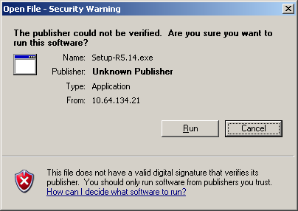

Click on button.

The wizard window appears like this.

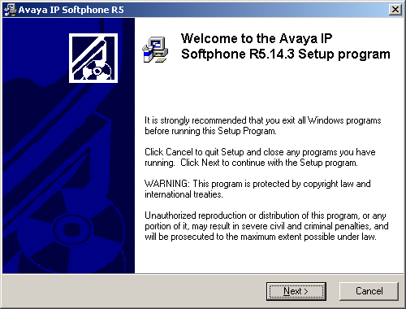

Click on  button.

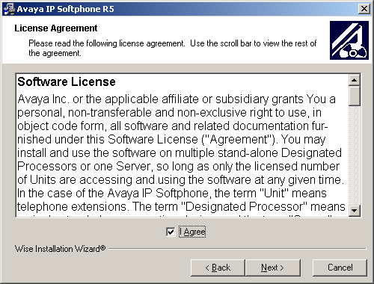

Check  button and then click  button.

You will find the below windows continuously and keep pressing  button until the  command comes.

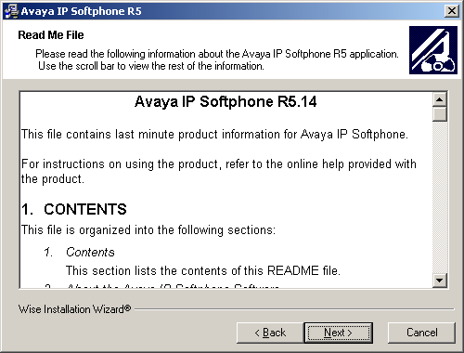

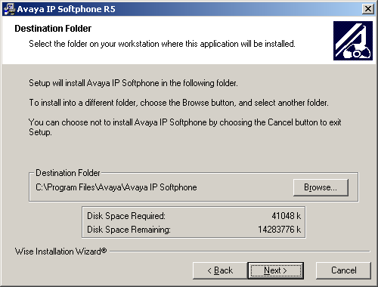

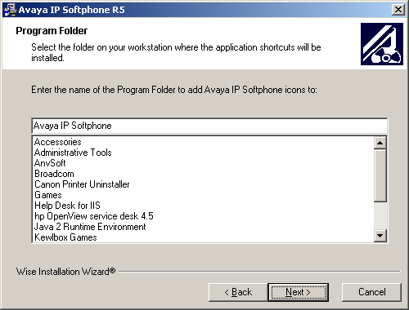

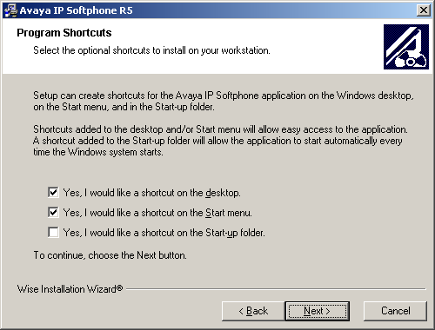

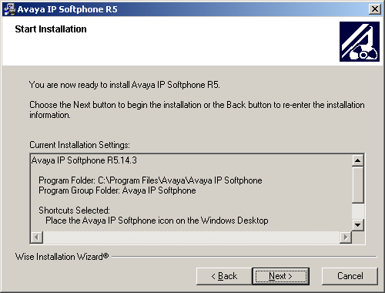

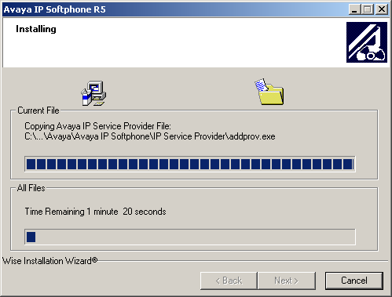

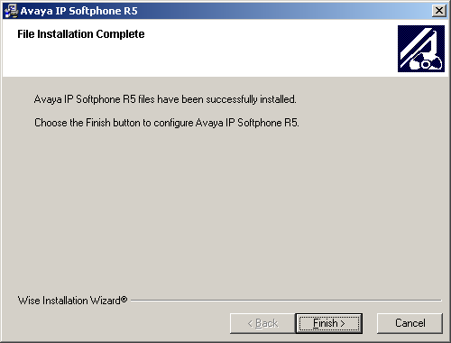

It is the last window and now click on .

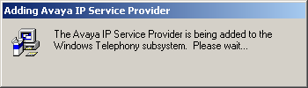

It will update the configuration and ask to wait so wait for some time.

Later you have to click on  button when you find the below window.

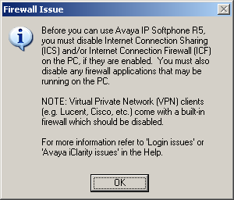

Again click on  for below window also.

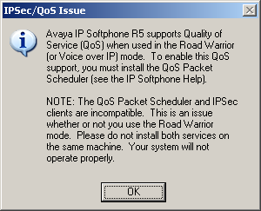

Later you have to install Service pack 1. It is available in \\10.64.134.10\d$\IP Softphone V5.1\IPSR5.1-ServicePack1.exe.

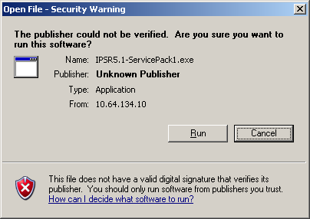

Click on 

Then the below window appears, in which you have to click on  button.

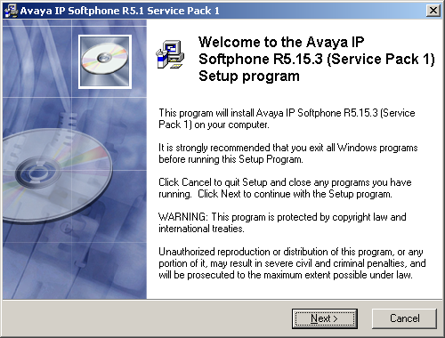

You will find the below windows continuously and keep pressing  button until the  command comes.

After the IP softphone got installed open the shortcut which is available on the desktop.

Then the system prompts you to configure the Avaya.

Find the below screen shots regarding the Configuration wizard.

